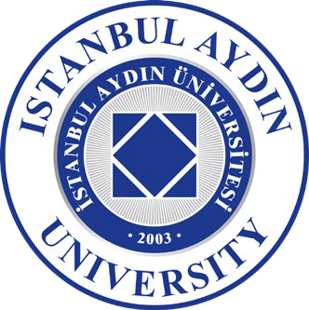

ISTANBUL AYDIN UNIVERSITY ERASMUS+ OFFICE

CONFIRMATION OF ERASMUS+ TRAINEESHI PERIOD
(DURATION SHEET)

The present form shall be completed by the Host Institution

Dear Colleague;
This form is used to record the Erasmus mobility duration of the student mentioned below at your institution. Thank you very much for your collaboration.

Istanbul Aydin University Erasmus+ Office

CONFIRMATION OF ARRIVAL TO HOST INSTITUTION

This is to confirm that (first name and surname of student)

has arrived at (name of receiving institution)

on, (date)

(signature and stamp of the host institution)

CONFIRMATION OF DEPARTURE
(to be filled at departure)

This is to confirm that (first name and surname of student),

student of Istanbul Aydin University has attended the Erasmus Placement Mobility Programme at

………………………………. (name of receiving institution)

And departured on, / / (date)

(signature and stamp of the host institution)

Istanbul Aydın University Erasmus Office
Beşyol Mah. İnönü Cad. No: 38 Küçükçekmece / İstanbul - TÜRKİYE Phone: +90 212 444 1 428 / Fax: +90 212 425 57 59 Email: erasmus@aydin.edu.tr

